**PROCESS INSTRUMENTATION**

**Name: Vivek Chandrashekhar Rugale**

**GR No.: 11810369**

**Div.: TY-C**

**Roll No.: 24 (Batch B1)**

**LAB 7:**

**Aim - Study and implementation of ON-OFF controller**

Implementation of ON-OFF controller in Python with neutral zone:

Code:

sp = int(input("Enter the set point temperature: "))

mv = int(input("Enter the measured temperature value: "))

nz = int(input("Enter the neutral zone : ")) #Here neutral zone is for positive or negative error

print("\n")

while True:

if(mv<=sp+nz):

print("Heater ON")

else:

while(mv>sp-nz):

print("Heater OFF")

mv = int(input("Enter the new measured temperature value: "))

print("Heater ON")

mv = int(input("Enter the new measured temperature value: "))

if(mv == 0):

break

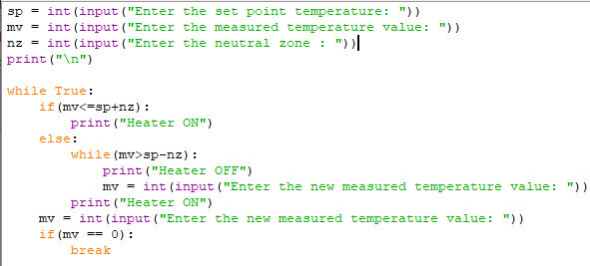

OUTPUT:

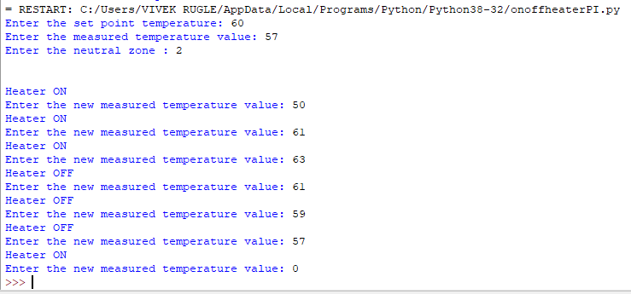

**Conclusion:**

Implemented the ON-OFF controller using python programming. Here neutral zone is 58 to 62 C in between which the controller will not change its current state as we can see it in the output.